The Best Ways to Make Mailchimp Work for Your Business
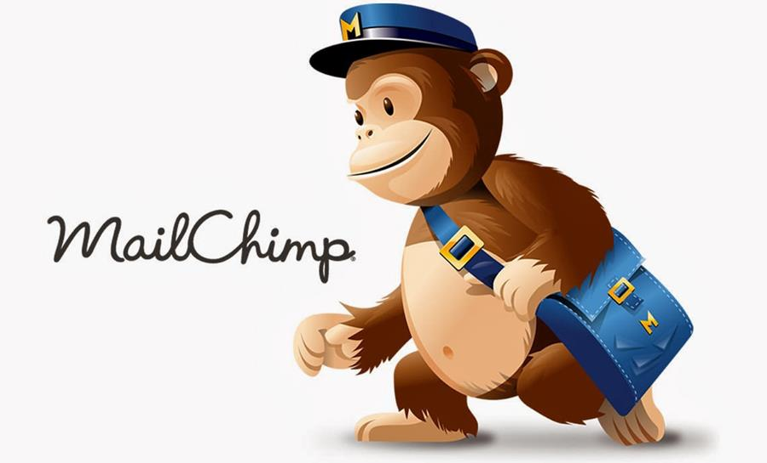
How can a simple mailing platform help you boost sales? The truth is, Mailchimp has many features that can help you sell more products.
Once you understand how to use Mailchimp, you can utilize it strategically by identifying audiences, giving out promo codes, running ads, analyzing data, and more.
Don’t underestimate the power of a mailing list!

What Is Mailchimp?
Mailchimp is an email marketing company. It was founded in 2001 by Ben Chestnut and Dan Kruzius.
It was first meant to be a side project to help Ben and Dan’s clients build email lists for surveys. It stayed that way for six years. The company brought in a couple of thousand dollars each month.
In 2007, Ben and Dan decided they didn’t want to be an agency anymore and would rather focus on Mailchimp. Instead of taking outside investments, they reinvested the profits they had initially been made back into the project.
Now, Mailchimp is one of the most well-known and popular email marketing platforms. In 2018, it was valued at $4.2 billion.
Mailchimp lets you send out emails to your audience, but it does much more than that. With its myriad of tools, Mailchimp will undoubtedly help you grow your business.

How Do I Use Mailchimp?
After Mailchimp walks you through the signup process, it’s your job to do all the heavy lifting. But before you even consider sending your first email, you need to think about who your audience is.
The first thing you’ll want to do is build your connections. The people you want to subscribe to your Mailchimp include business connections, leads, and customers.
Mailchimp creates a signup form for all the mailing lists you make, which you can then share on your social media accounts and your website.
There are many moving parts on Mailchimp. But, once you understand them, everything will make sense, and you can start using it to your advantage!

What Is My Dashboard?
On your dashboard, there are 5 different tabs you can click on.
- Campaigns are the emails, landing pages, and more that you publish and send to your customers.
- The Templates page is where you dream up the content and designs for your campaigns.
- Audience is where you manage your mailing lists.
- The Reports page is where you can view how your campaigns are performing. You can see who is engaging with your content, and then you can use that information to better your campaigns.
- Content Studio lets you view things like images, gifs, and logos.

How Do I Send Out a Campaign?
You can design a format using Mailchimp’s templates feature. Templates are reusable, and once you have a template you like, you can use it as the basis for all your emails.
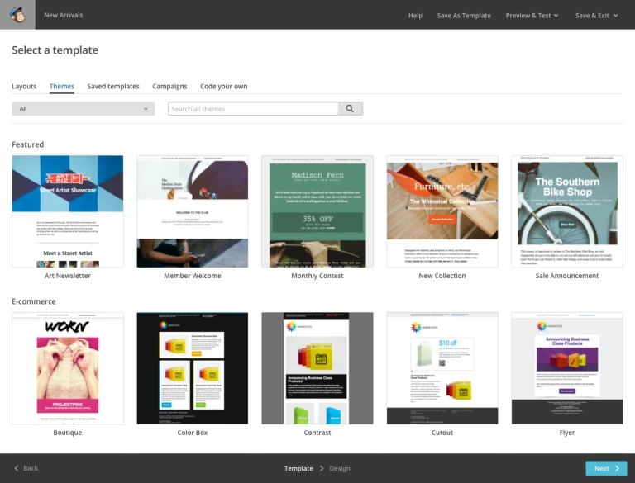
Now that you have your format use the campaign feature. Create a campaign name and click Begin. Add your list of recipients.
Now, design your email.
Utilize Mailchimp’s preview and test tools. With the preview button, you can see what the email would look like on a mobile device, and with the test function, you can send yourself (or anyone you’d like) a test email.

How Much Does Mailchimp Cost?
There are a couple of tiers to Mailchimp pricing.
- Free: Up to 2,000 contacts and 10,000 emails per month, with ads.
- $9.99/month: 5,000 contacts and 500k emails.
- $14.99/month: Adds advanced automations.
- $299/month: All-areas access.
Beyond tiers, there are other pricing options. They have a cost calculator, so you know how much you will have to pay when you reach a certain number of subscribers.
There are also pay-as-you-go plans. You prepay your email quota, and that prepayment is suitable for up to a year. At 5,000 emails, you pay $0.03 per email, and after 10,000 emails, you only pay $0.02 per email.

What Can You Achieve with Mailchimp?
Mailchimp has many features to help you sell more things to your audience.

Identifying Customers
First, you connect your store to Mailchimp. After this, you’ll have many e-commerce tools under your belt.
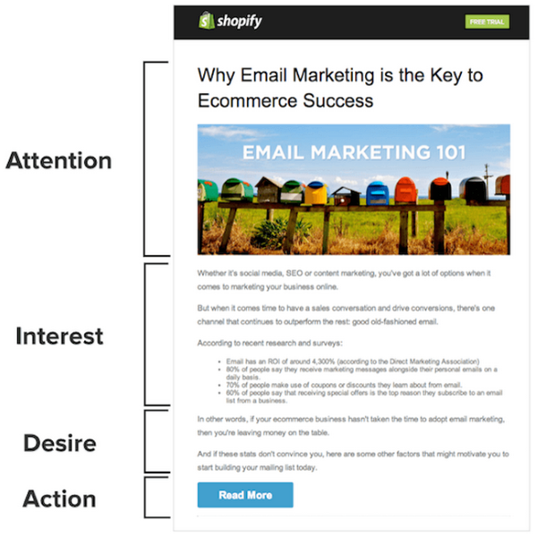
You can use the data that Mailchimp provides you to boost sales. It will help if you use promo codes, product recommendations, and customer segments.
One thing to try is sending an email to a targeted segment of your mailing list. If you segment your audience based on their purchasing activity, you can tailor your emails to the enthusiastic crowd with offers and coupons since they’ll likely use them.

Automation
Mailchimp offers welcome messages, abandoned cart notifications, and order receipts. You can create up to 16 times more orders with the correct automation.
Set up abandoned cart emails. People have lives to live, and most people who have an item in an online shopping cart will abandon it.
By sending out abandoned cart emails, you will remind people that they want your product.
You can also automate beautiful welcome emails that will make new subscribers feel special. Use this opportunity to introduce yourself, send a coupon, and familiarize your customer with your products.

Run Ads
Mailchimp can help you run ads! Mailchimp has an Ad Builder where you can create ads for Facebook, Instagram, or Google.
There are two different strategies for running ads. One is to cast a wide net and reach new people. Another is to retarget people who have visited your website in the past.
https://www.youtube.com/watch?v=IWeCs6oNeks

Use your ROI and Results to Your Advantage
Once you’ve added product recommendations, built ads, and sent automation, you can watch all the data play out.
Mailchimp has graphs and charts that are easy to read and help you understand what’s working and what isn’t.

Final Thoughts
Mailchimp is a powerful tool!
There are many different aspects of its interface, so there may be a learning curve at first. But once you get the hang of it, it can be one of your business’s most powerful assets.
With options to automate emails, create ads, identify customers, and more, Mailchimp is much more than just an email platform.
You would be remiss to overlook Mailchimp and its ability to help you build an audience and boost revenue!

